Tool List for Advanced Cello Setup
Learning Trade Secrets March 2019

It is assumed that all students signing up for the above class will have a complete set of cello tools. Please bring all tools that are necessary to complete the tasks during the week. Should you have questions regarding tool selection, consider the Agenda/Topic Milestones list in your decision.

Your instructor would prefer that you order and bring the following Cello Bridge models. It will be helpful to have one of each to complete the bridge cutting project.

Tool List for Advanced Cello Setup
Learning Trade Secrets March 2019

Cello Bridge Materials
Please bring 1 Belgian model and 1 French model Cello Bridge blanks. Preferred bridge foot width is 90mm. Pick from the following choices.
Order from Metropolitan Music. Contact information;
Call 866-846-5461 to set up a wholesale account. Or, you may email at sales@metmusic.com.
DesPiau Bridges
Belgian Model—12721-C11-B grade. Or 12723-C15-B grade.
French Model—12795-C9-A grade. 12714-C9-C grade.
Milo Stamm Bridges
Belgian Model—12944-B Standard
French Model—12964-F Standard.

Tool List for Advanced Cello Setup
Learning Trade Secrets March 2019

The following tools are all suggestions that will help make some of the week’s tasks easier. It is not required that you purchase any of them. Bring any similar tools that you feel might work for each task.

Tool List for Advanced Cello Setup
Learning Trade Secrets March 2019

Fingerboard Tools and Material Suggestions

Lie Nielson Planes
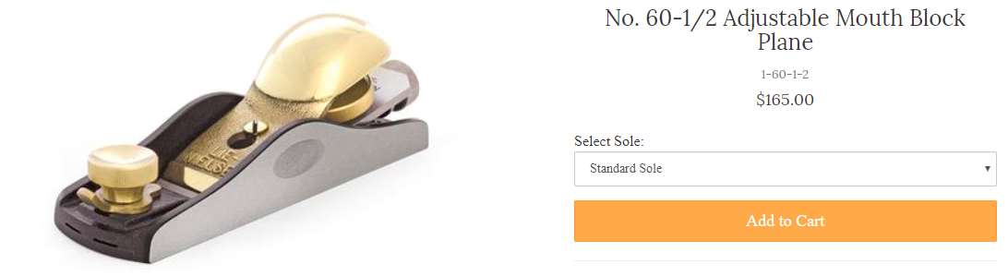

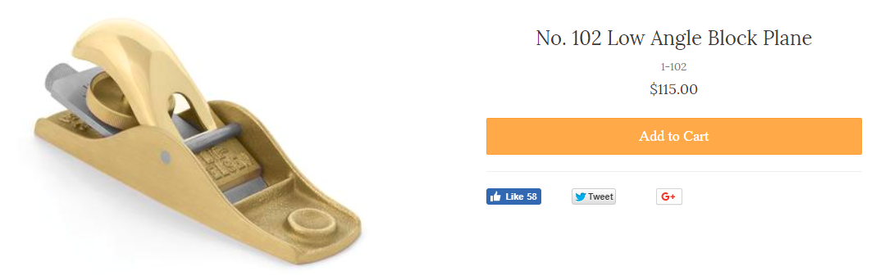

Bridge City Tools
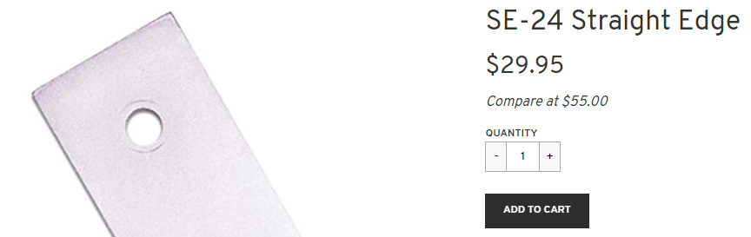
Tool List for Advanced Cello Setup
Learning Trade Secrets March 2019

Fingerboard Tools cont.

Autobody Tool Mart
https://www.autobodytoolmart.com/3m-stikit-gold-sheet-2-34-sandpaper-rolls-p-11340.aspx

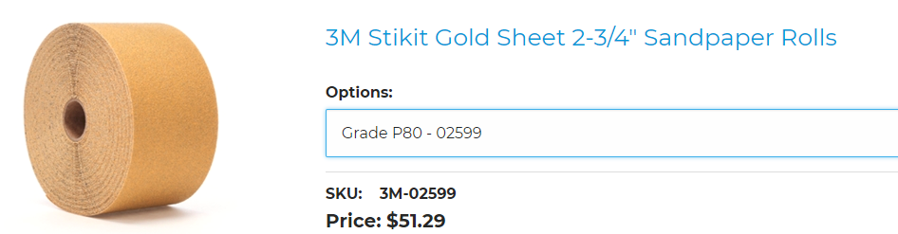
P80, P120, P180 Grits all recommended for fingerboard sanding.

Fingerboard Templates—Preferred ‘Blue Steel’ models. Order complete set (violin, viola and cello) from Paul Weissmeyer Violins. Boston, MA Call Paul direct at 1-617-262-2688 to place order.

